Jesus Nolazco

Chapter 2

10/04/21

Assignment 02-1

Pages 21-22

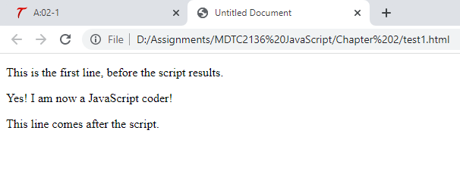

<!DOCTYPE html>

<html>

    <head>

        <title>Untitled Document</title>

    </head>

    <body>

        <p>

            This is the first line, before the script results.

        </p>

        <script>

            document.write("Yes! I am now a JavaScript coder!")

        </script>

        <p>

            This line comes after the script.

        </p>

    </body>

</html>

Try This 2-1

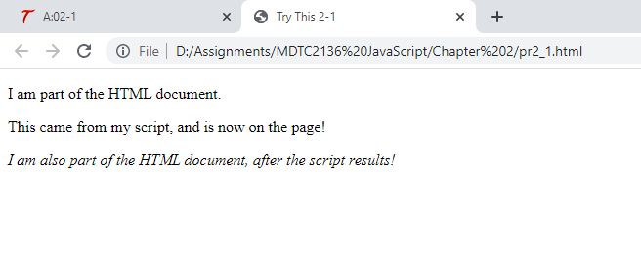

<!DOCTYPE html>

<html>

    <head>

        <title>Try This 2-1</title>

    </head>

    <body>

        <p>I am part of the HTML document.</p>

        <p>

            <script>

                document.write("This came from my script, and is now on the page!")

            </script>

        </p>

        <p>

            <em>I am also part of the HTML document, after the script results!</em>

        </p>

    </body>

</html>

Try This 2-2

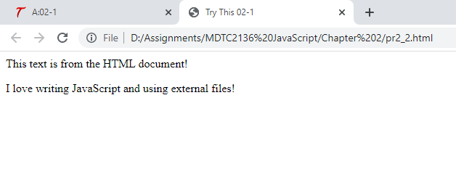

<!DOCTYPE html>

<html>

    <head>

        <title>Try This 02-1</title>

    </head>

    <body>

        This text is from the HTML document!

        <p>

            <script src="prjs2_2.js"></script>

        </p>

    </body>

</html>

document.write("I love writing JavaScript and using external files!")